**CSI3007 -ADVANCE PYTHON PROGRAMMING**

**LAB ACTIVITY 7**

**ERRORS**

**G REENA SRI**

**22MID0009**

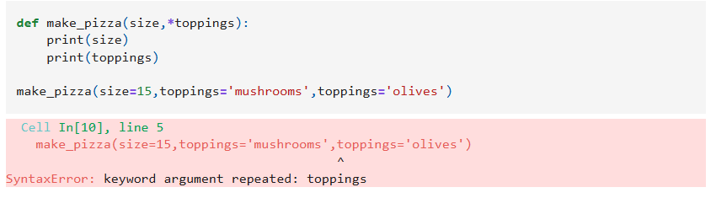

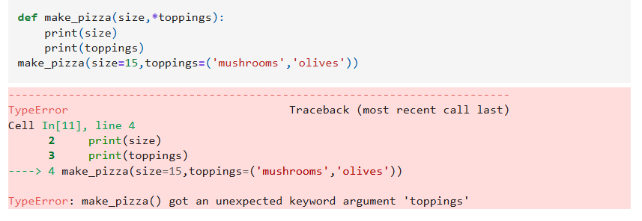

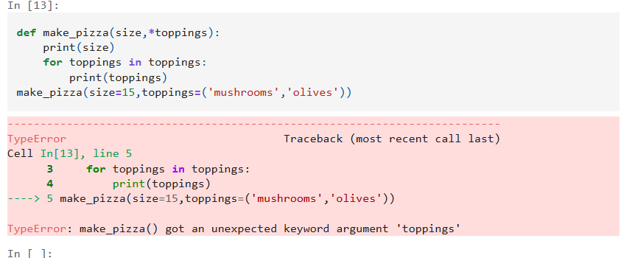

Errors : Traversal problem .

Fixing Code :

def make_pizza(size, *toppings):

*# size is a postional and toppings is a keyword argument*

print(f"\n Making a {size}-inch pizza with the following toppings")

for topping in toppings:

print(toppings)

make_pizza(16,"pepperoni")

make_pizza(22,"pepperoni","mushrooms", "green pepper","extra cheese")